Dear Karine and Michel

I am carrying out a meta analysis of genetic diversity patterns across the Pinnipedia and am gathering together microsatellite datasets (I already have 27 different species / subspecies covered).  I wonder if you would be willing to share your *Phoca largha* microsatellite dataset, published in Trends in Evolutionary Biology 2010: 2:e6.   Unfortunately I could not find the data in DRYAD or any other repositoty.  I would only use the data for the purpose stated.

Many thanks and best wishes,

Joe Hoffman

Joe Hoffman

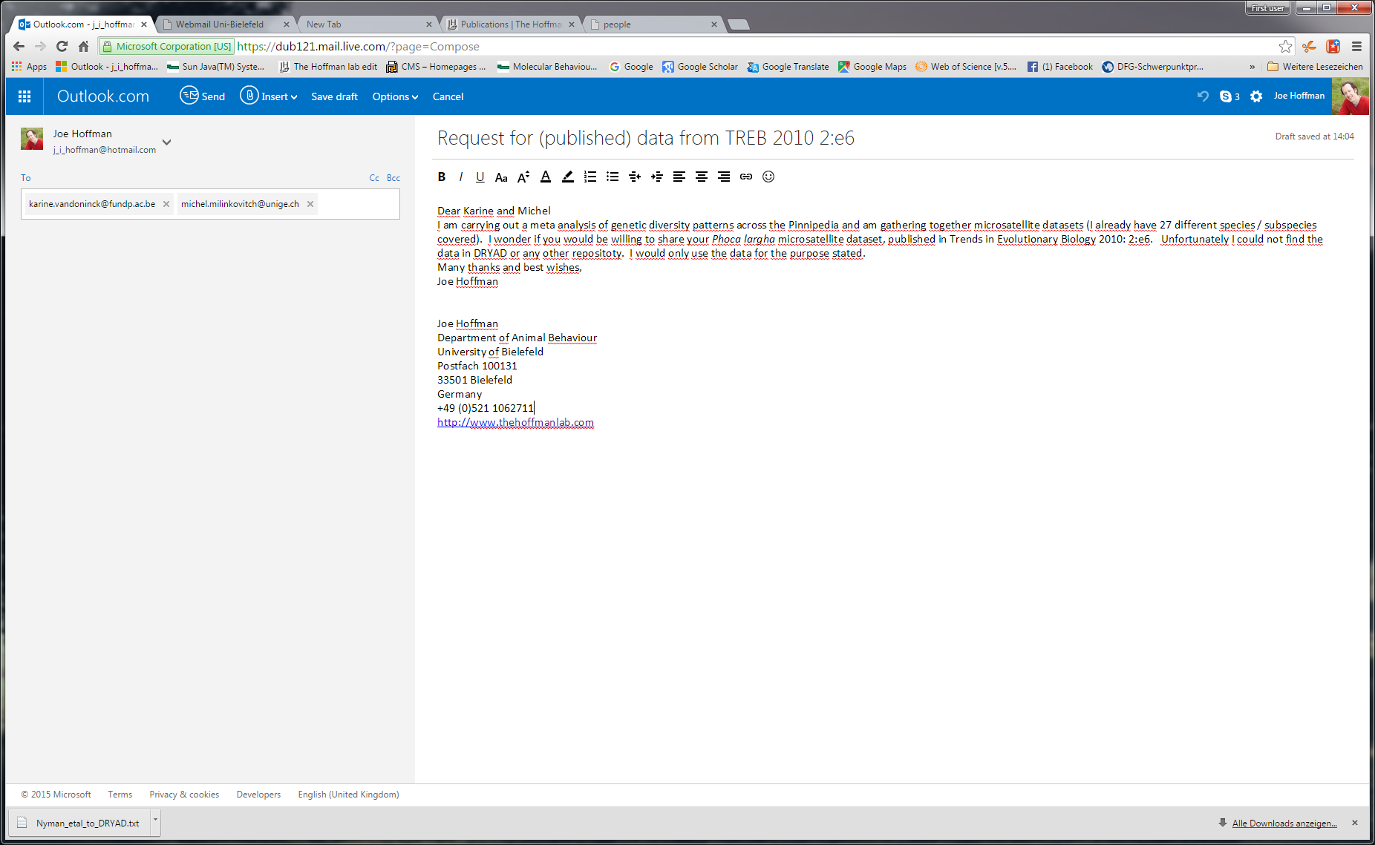  
  
Dear Melanie

How are you?!!

Would you be willing to send me your m'sat dataset for the paper published in animal conservation 13: 2010 247-255 on Australian fur seals? I am working on a meta analysis of pinniped genetic diversity and have data from 29 species already. It would be wonderful if I could include your data for Australian fur seals. all the best

Joe

via linkdin